**Peachstate PCA Color 4 inch 300 ppi CMYK.tifPeachstate Region**

**Porsche Club of America**

**Driver’s Education Manual**

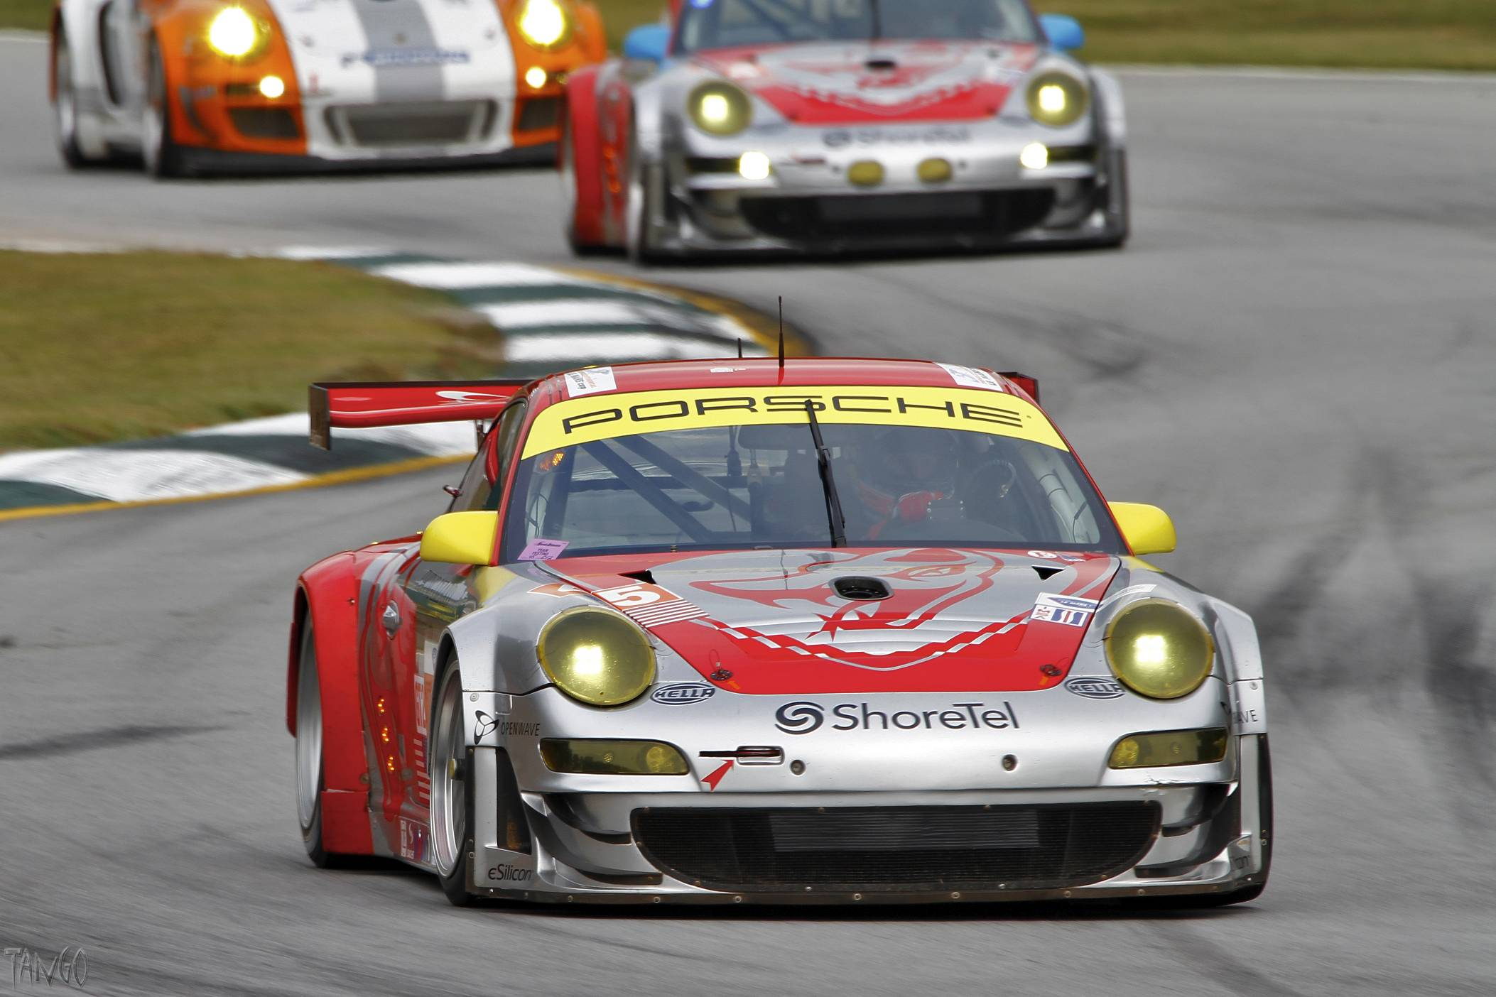

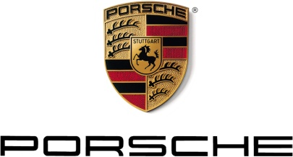

Written by John Krzymuski ([radvan@bellsouth.net](mailto:radvan@bellsouth.net)) for Peachstate Region, PCA. Feedback to the author is sought in an effort to improve this guide.

Photo by David Wilks

“Smiley” symbols - ☺ ☹ - indicate a warm (or cold) ‘feeling’, an attempt at humor, or even irony. Comments followed by a “smiley” are not intended to be taken seriously.

© 2012 John Krzymuski

Revised 17Jul2022

**Table Of Contents**

1. Introduction 6

2. What Is Driver Education? (The 'Officialese') 7

…In other words 7

3. DE – Frequently Asked Questions 8

Is my car eligible? 8

What about my Cayenne / Macan / Panamera? 8

Am I eligible? 8

Can I participate if my car has an automatic, PDK or Tiptronic transmission? 8

Will a DE Event harm my Porsche? 8

Will I be able to keep up with everyone? 8

Is my regular car insurance valid on the track? 9

Do I have to make any modifications to the car? 9

Do I need a helmet? 9

Do I get instruction? 9

What are Run Groups? 10

What happens if it’s raining? 10

Can both my spouse and I drive at an event? 10

Can family members or friends ride with me? 10

Can I come for one day only? 11

How do I find out about Peachstate DE events? 11

4. DE Event Administration 12

General schedule 12

Registering for a Peachstate DE Event 12

Using Clubregistration.net 12

Registering for a DE event 13

Payment 13

Sharing a Car 13

Acceptance and Status 13

Cancellation 14

Event Organization 14

Michelin Raceway Road Atlanta 14

Sunday Morning ‘Quiet Time’ 14

5. Mandatory Safety Equipment 15

Helmet 15

6. Pre-Event Preparation 16

Accommodation 16

Spectators 16

Technical Inspection 16

Car Number 16

What Do I Need To Bring? 17

7. At Last…… 19

Getting to the track 19

When you arrive at the track 19

Registration 19

Entering the Paddock 20

Preparation for Trackside Tech 20

Car Number 21

Trackside Safety Inspection “Tech” 21

Rogues Gallery 22

Drivers Meeting 22

Track Familiarization 23

Classroom Sessions 23

Evaluation Forms 23

Preparation For Driving 23

Clothing 23

The Weather 23

Seating Position 23

Mirror Adjustment 24

Windows & Sunroof 25

Tire Pressure 25

Staging 25

Communicators 25

It’s All In The Mind 25

On the track 26

Flag Signals 26

Passing Zones 26

Overtaking Signals 27

End Of Run 27

Condition of your car 28

Your condition 28

8. Miscellaneous Tips 29

Your Well-Being 29

Lug Nuts 29

Engine Coolant 29

Sneaker Whitener 30

Removable Car Numbers 30

Keys in Car 30

9. Safety And Performance Modifications 31

Harness, Seat and Roll Bar/Cage 31

Brake Pads 32

Brake Fluid 32

Brake Rotors 32

Driving Shoes 33

Driving Gloves 33

Driving Suit 33

Head and Neck Support device (HANS) 33

10. Resources 34

Car Numbers 34

Helmets 34

Internet 34

Performance Driving Books and Articles 34

DE Insurance Resources 35

11. Flag Descriptions - READ...UNDERSTAND...AND MEMORIZE 36

12. Run Groups and Advancement Policy 38

Group 1 38

Group 2 39

Group 3 (Advanced and Instructors) 39

Group 4 (Expert and Instructors) 39

13. Personal Checklist 40

14. Driving Directions and Local Hotels 41

From I-85 41

From I-985 41

Local Hotels 41

15. Peachstate PCA Driver Education Event Rules 43

16. Road Atlanta Rules 47

# Introduction

Welcome!

You are probably reading this Peachstate PCA Driver Education Guide as a result of a visit to our Web site, maybe as a result of wondering what “DE” is all about. This text is intended to help you in your preparations and to provide information about what to expect once you get to the track. If you are considering, or if you have already made the commitment to a Driver Education (often abbreviated to ‘DE’) event, please take the time to read this Guide. The better you are prepared, the more you will get out of the event.

So what’s contained in this Guide?

Chapter 2 explains the aims and objectives of the DE event – the ’mission statement’ if you like – both in the official language and a personal, unofficial interpretation.

Chapter 3 gives answers to frequently asked questions from beginners about DE events

Chapter 4 explains how to register and a how a typical day is organized.

Chapter 5 explains about the safety equipment required to participate at an event.

Chapter 6 takes you through pre-event preparation such as what to bring to the track, accommodations near the track and getting your pre-event technical inspection.

Chapter 7 covers your arrival at the track, what to expect and where, how to prepare your car and yourself. This chapter also covers important information that you need to know when you are on the track, such as the hand signals you may give.

Chapter 8 is a gathering place for some miscellaneous tips.

Chapter 9 is aimed at more advanced drivers and discusses some of the safety and performance related changes you may consider making to your car.

Chapter 10 provides a short list of various other resources that may prove useful, including local suppliers of equipment, Internet sites, companies offering specialist DE insurance and books on performance driving.

Chapter 11 contains important information about the flags you may see around the circuit. As a student driver you must know and understand the meaning of and the expected actions for each of the flags.

Chapter 12 explains the run group system in detail; What is expected of drivers in each group, and the club policy for advancement from group to group.

Chapter 13 contains a summary of the personal checklist (from Chapter 6) of items you may want to take to the track.

Chapter 14 provides driving directions to Road Atlanta and a list of local hotels.

The final two chapters list the formal rules for the event - the Peachstate PCA rules, which have been discussed in this Manual and the Road Atlanta rules.

# What Is Driver Education? (The 'Officialese')

The mission and purpose of the Porsche Club of America's Driver's Education Program is to provide a safe, structured and controlled teaching and learning environment. The PCA DE Program is designed so that participants can improve their driving abilities and acquire a better understanding of vehicle dynamics and driving safety. Participants will experience first-hand the capabilities of high performance automobiles in a controlled, closed-course environment and acquire skills that will enhance safer vehicle operation in all driving situations.

**One giant word of caution**: this adventure can become very addictive. Our instructors will teach you to drive your Porsche the way Stuttgart designed it to be driven. PCA DE schools are run in a safe and controlled environment on a closed course. Like any new sport your instructor will guide you into this exciting world of high performance driving. These weekends are great sources of stories for the Monday morning coffee break. You will have dreams about various turns and wake up with memories of your instructor yelling “BRAKE” or “DON'T LIFT”. These schools are truly the only safe way to learn the engineering dynamics that went into the development of this famous racing marque. However, it is noted that PCA DE events are not racing, nor preparation for racing. No times or placings are recorded, and no awards or prizes are received by the participants of PCA Driver's Education events; just a lot of fun and camaraderie. Any conduct considered by the Porsche Club of America to be either unsafe or inconsistent with the spirit or purpose of the Driver's Education Program will not be permitted. This approach keeps the events safe for all participants!

## …In other words

Driver Education events allow us to learn more about our Porsches, to learn more about ourselves and, above all, to have fun. You’ll learn the rudiments of performance driving in a safe, controlled, and non-competitive environment and be able to use the experience to improve your safety and driving ability on the street. In fact DE events are one of those rare enjoyable things in life that aren't illegal, immoral or fattening ☺. You'll learn, at first, that the limits to how you drive are yours and not your Porsche’s. You'll find you have to push yourself harder to approach the limits of the handling of the car and, with your instructor beside you, you will learn to recognize these limits and to control the car as it approaches them at relatively low speed.

Many of the lessons learned from a DE experience can be carried over to street driving and you should end the day with an increased confidence level in your own and the car’s abilities.

The events are organized with safety as the paramount consideration and with the aim of providing enjoyment for all. Driver Education events are ***not***races and are ***not*** competitive events. By requiring a signal from the driver in front to permit a pass - and taking cars off the track if they fail to obey the rules - the competitive element is eliminated. Your ego and pride should not be dented if another car passes you. On the contrary, you should help the other driver get around you while you concentrate on driving your car totally accurately. Remember: the only prize you can win is to get to drive your car home in the same state in which it arrived.

If you want a competitive event then why not try your hand at other Peachstate events that are competitive in nature, such as the Autocross, Concours or Rally?

# DE – Frequently Asked Questions

This section attempts to answer some of the questions that many beginners ask about doing a DE event. Don’t worry if you don’t understand all the terminology in the answers – the terms will become clear as you read through this Guide.

## Is my car eligible?

Any make of car delivered with factory installed roll over protection meets the minimum standards for PCA DE events. In these cars the soft top must be in the up position or the hard top installed.

If a car does not have factory installed roll over protection, a roll bar must be installed, which meets the "broomstick" rule: The driver's helmeted head is below a bar placed on top of the roll bar and windshield. The windshield alone is not considered to be factory roll over protection.

Soft-top Porsches without roll bars are not eligible. All targa tops must be installed, unless there is additional roll over protection. All sunroofs must be in the closed position. Hard-top Porsches do not require a roll bar.

## What about my Cayenne / Macan / Panamera?

Both Cayenne’s and Panamera’s have run successfully in DE events. If you are interested in doing a DE event, please go ahead and register as normal.

## Am I eligible?

If you are over 18 years of age and have a current driver's license then, yes, you are eligible. If you are a Porsche owner but are not yet a member of PCA, you may read about membership at the PCA Web site [www.pca.org](http://www.pca.org) where you may also download an application form. PCA membership allows you to nominate a family member or friend to be a member at no extra cost.

## Can I participate if my car has an automatic, PDK or Tiptronic transmission?

No problem. A manual shift is not a pre-requisite for a DE event. In fact, as a beginner, learning may be simpler as you do not need to be concerned with shifting on the track. Come along and give it a try.

## Will a DE Event harm my Porsche?

Porsche’s have followed a long tradition of over-engineering its components and as a beginner it is unlikely you’ll be stressing any of its mechanical components. The old saying that "Every Porsche Built is a Race Car" has a solid foundation. They are built to be driven and are in their element on the track. Cars used for DE are often better maintained than street-only cars with owners ensuring they are in tip-top mechanical condition. A pre-event technical inspection ensures it is in safe and suitable condition for your DE event.

Some people may be concerned about stone chips or other cosmetic damage. A good coat of wax, along with judicious use of a bra and/or racers tape can all but eliminate any cosmetic damage. That said, if you are overly concerned about an occasional stone chip, DE may not be for you. Come and join in our Concours events instead!

## Will I be able to keep up with everyone?

You should have no trouble whatsoever because you’ll be driving with other drivers with the same experience as you. You *won’t* be on the track with faster, more experienced drivers. In other words novices are only on the track with other novices, and all students have an instructor in the car with them.

## Is my regular car insurance valid on the track?

The short answer is ‘almost certainly not‛. This is an evolving area and one of the noticeable trends over the last few years has been the addition of clauses in standard insurance policies that effectively exclude coverage at DE events. In the past, most policies excluded competitive events (such as autocross and racing) but because Driver Education is not competitive, it was generally covered.

Nowadays however, clauses excluding accidents on any sort of “racing surface” or “Used in a high performance driving or racing instruction course or school” are appearing in the exclusions section of policies.

You would be well advised to read the exclusions page of your policy to confirm there isn‛t language that would exclude DE events (for example, excluding any event on a track). If you don’t find such language you may be happy to leave it at that, Or you may wish to talk to your agent but if you do so make sure to get the answer in writing from the head-office underwriter. Answers from agents may be wrong! Don‛t assume that insurance companies know anything about DE. Be sure to understand and explain that DE isn‛t racing, is a non-competitive, non-timed event with no prizes, no placings etc. etc.

However, all is not lost! Nowadays it is possible to get physical damage insurance specifically for DE events. PCA has a relationship with “[Lockton Affinity](https://locktonmotorsports.com/hpde-insurance/)” for DE insurance at preferred rates.  The program can be tailored to your DE activity, allowing you to choose insurance for a single event or multiple events in an annual policy. You can get a quote and purchase the policy on-line. Just click on the link above.

You may also seek coverage from other providers, if you choose. See the ‘Resources’ section at the end of this guide.

## Do I have to make any modifications to the car?

If you are a beginner attending your first few DE days the answer is “No”. Once you graduate to higher “run groups” (see the “Event Organization” section in Chapter 4) you may want to add various other safety or performance enhancements. If you are thinking of installing harnesses, please read Chapter 9 for information about PCA rules for such modifications.

## Do I need a helmet?

Any driver or passenger on the track ***must*** be wearing a helmet. You may have friends who can lend you one, or you can purchase a helmet. See Chapter 5 for more details about helmets.

## Do I get instruction?

As a beginner you will receive both classroom instruction and on-track instruction. In the classroom sessions you will be briefed on the terminology that will be used by your instructor, basic performance driving concepts, safety and flag meanings etc.

An instructor is assigned to you for the day. They will discuss your progress throughout the day. There is no extra charge for instructors.

## What are Run Groups?

The Event Chair and the Chief Instructor work together to assign drivers to a run group based on your track driving experience. You will wear a wristband that indicates your run group, and your car has a sticker that also indicates your run group.

The run groups are:

|  |  |  |
| --- | --- | --- |
| **Run Group** | **Basic Description** | **Instructed** |
| 1 | Beginner driver with little or no track driving experience | Yes |
| 2 | Solo drivers, still learning technique | On request |
| 3 | Advanced drivers and Instructors | No |
| 4 | Expert and Instructors | No |

You start in run group 1, and move to a higher run group as your skill improves. There is no pre-defined schedule for how long it takes to progress to the next run group. That depends purely on your abilities, your skill and your experience. You will receive check rides from senior instructors to advance from one run group to the next. Please read chapter 12 for full details of the standard expected for drivers in the various Groups.

## What happens if it’s raining?

The event is run come rain or shine although if conditions are extremely poor the Chief Instructor may cancel run sessions. Of course, when it is wet you will be driving somewhat slower as your tire grip is reduced.

## Can both my spouse and I drive at an event?

If you are going to share a car you will need to be in different run groups. Of course if you have ‘His’ and ‘Her’ Porsches you have no such problems ☺. Also, read Chapter 4 for more information about registering with a co-driver.

## Can family members or friends ride with me?

Only registered drivers are permitted on the track and if there is a second person in your car, they must be an instructor. So you won’t be able to go out with your spouse or with friends. Once you have progressed out of the beginner’s group why not share your car with your spouse and both experience Driver Ed?

However, on Sunday mornings, charity “Track Touring” rides are possible. Cars, vans and SUV’s drive in a low-speed convoy around the track and you are welcome to drive your friends and family around in your Porsche, SUV, or any other vehicle. Family members and friends are allowed to ride along during the track tour. It’s a great way for first-timers and their spouses, who are not quite sure what is actually involved in a DE, to experience it firsthand.  The Touring sessions are used to raise money for a local ‘good cause’ and a minimum charitable donation of $20 per car is requested.

## Can I come for one day only?

Peachstate DE events are at weekends and just as each event builds on the last, each day builds on the previous. If you can only participate on day 1 that is permitted; However, the fee is the same as if you were attending the entire event – there are no discounts for single days. You may not come only for day 2.

## How do I find out about Peachstate DE events?

If you would like to be informed of upcoming Peachstate PCA Driver Education events, simply check the club website <http://www.peachstatepca.org/calendar> or take a look at [www.clubregistration.net](http://www.clubregistration.net) where the complete Peachstate schedule is published. You will need to set up a user account, but you will need it to register once the event is open. (See next section)

# DE Event Administration

The following sections deal with the general administration of DE events. Learn about how events are organized and how to register for an event.

## General schedule

In general, Peachstate region run three events per year in April, June and October. Obviously the specific schedule dates vary slightly from year to year so check the Region web site, [www.peachstatepca.org](http://www.peachstatepca.org), the ***Peachstate Presse*** or the registration site, [www.clubregistration.net](http://www.clubregistration.net) for information.

## Registering for a Peachstate DE Event

You will need to check on the club web site to find out when registration for a specific event is opening, typically some six weeks before the event.

All registration for Driver's Education events is done via the online service [clubregistration.net](http://www.clubregistration.net/).  If you do not already have your profile set up on clubregistration.net we recommend that you set up your profile now in order to expedite the process of actually signing up for your first Peachstate event.

Signing up on clubregistration.net is useful not only for DE registration, but also for registration for other types of events held by Peachstate PCA such as Autocross and Tours as well as other PCA region events.

It is recommend you sign up as close to the opening time as you can to improve the chance to be accepted. Your priority is determined by the time stamp for receipt of your payment, so use of the on-line payment option is highly recommended. Entrants who register after the appropriate run group is filled are placed on a waitlist. We offer the opportunity to move from wait list to accepted status based on the same timestamp priority, as cancellations occur.

Please be sure you also complete the event options selection, such as t-shirt size, as well as complete the online ‘Emergency Contacts’ section in your profile.

## Using Clubregistration.net

If you haven’t used [www.clubregistration.net](http://www.clubregistration.net) before, there are a few steps you need to do before you can complete your first DE application. You must create an account for yourself with a username and password. This is done by clicking on the “Create Account” link just under the login section.

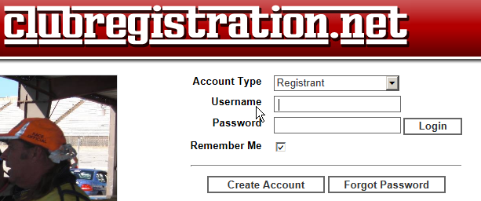Once you have an account, you will need to add your background information. The sections below need to be completed before you can complete your DE application but it will only take a few minutes. The good news is that once it’s done, you will only have to update it when your

information changes. When you create an account you give a user name and a password, your name and address, an Emergency contact and any experience you may already have had. Once your account has been created you can log on and add details of you vehicles(s) and what car club(s) you belong to.

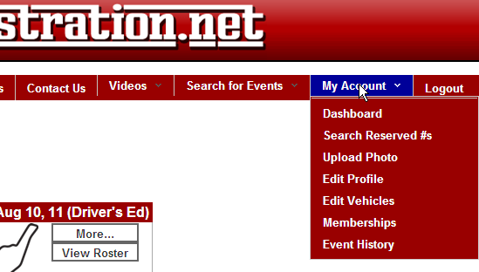The sections you need to complete are all found under the “My Account” option at the upper right side of the main screen.

If you start at Edit Profile and ‘Continue’ at the end of each screen, you will fill in all the required information. Complete all the required information (indicated with *) on these forms.

Notes: (i) The email address you enter is used for all communications regarding events so it is critical that it is correct.

(ii) Registration fees are lower and priority is given to PCA members so make sure you have your PCA Membership number entered correctly in the “memberships” area.

(iii) Be sure to click the “ADD” button once you’ve entered the information and before you leave the screen!

## Registering for a DE event

Use the “Search for Events” option, the final option on the top right hand side of the screen to find the Peachstate DE event you want to register for. (Hint: Do a search “By category”, set the Organization as “PCA”, Club as “Peachstate”, and Event Type as “Driver’s Ed”.)

Click on the "Details/Register" button for event to get to the information and policies for the event, then click "Register". Go through the Entry Fees, Vehicle, Event Options, Questions, Emergency Contact and Profile tabs, filling in or selecting data as appropriate. Much of the information is already pre-filled, based on what you entered when you created you profile.

## Payment

When you submit your application, you are directed to an “Events Payment” screen. PLEASE REVIEW THE ENTIRE PAGE TO BE SURE IT IS ACCURATE! You can submit payment via PayPal or credit card. Remember - acceptance into an event is based on date of your payment, NOT the date of registration so send your payment as soon as you can.

## Sharing a Car

You may share your car with a co-driver if you wish. Each driver needs to fill in their own form and the drivers will be in different run groups. For this reason sharing a car is not recommended if both drivers are beginners. Each driver pays the event registration fee.

## Acceptance and Status

Once your registration has been processed and has been accepted you will receive an email confirming the event.

You will be able to check your status on the [www.clubregistration.net](http://www.clubregistration.net) site by viewing the “Roster” for the event. All applicants have a status of “Pending” until payment is processed. Once your application has been processed, (you did log in and register real early didn’t you?!) the website will send an email letting you if you've been “Confirmed” or “Waitlisted”.

If you are “Confirmed” it means that your application has been processed, and we look forward to seeing you at the event. The email will provide you with the additional information you need, such as lodging information, the Tech Form, etc.

If you are “Waitlist”, all is not lost because people do cancel and their spots are filled from the Waitlist. You will be contacted via email regarding the next steps but if you do not get confirmed, your money will be refunded.

## Cancellation

Our cancellation policy allows for a full refund less a $100 cancellation fee for cancellations RECEIVED IN WRITING after acceptance and by 21 days prior to the event.  ANY cancellation received after the 21-day period is ineligible for any refund.  “Received in Writing” means received at the event registrar email address, with receipt requested to: ([DE-Events@peachstatepca.org](mailto:DE-Events@peachstatepca.org))

## Event Organization

The track at a typical DE event opens at 6:30AM. Trackside tech inspection is usually open from 6:30AM to 7:30AM. A drivers meeting at 7:30AM is followed by the first run group getting on the track around 8:30AM. We stop for an hour at lunch (actual times depend on run group) and continue until 5:00PM.

All DE entrants are divided into “Run Groups” according to experience and ability. (See the “FAQ” section). Each run group gets 25-30 minute sessions on the track, typically 4 per day. When you register at the track you will be given a timetable. Keep it handy so you know when you are due to drive, and pay attention to the Public Address announcements for schedule changes.

## Michelin Raceway Road Atlanta

Peachstate region is fortunate to have access to this great circuit originally constructed over 50 years ago. Road Atlanta is world famous among competitors and fans as one of the finest road circuits in the world. This great road course was refined in 1998 and 1999 and most recently in 2007, providing many challenging driver training areas. Our events utilize the Grand Prix layout with the twelve turns and numerous elevation changes. This 2.52-mile circuit has something special for every driver no matter what your skill level.

## Sunday Morning ‘Quiet Time’

There are several local churches and communities within earshot of Road Atlanta. As track users, we need to respect the local community. As a beginner with a street-muffled car (less than 98dB), you won’t have to worry about the noise regulations, but they are as follows:

|  |  |
| --- | --- |
| SATURDAY | ABSOLUTELY NO UNMUFFLED ENGINES STARTED PRIOR TO 8:00 AM |
| SUNDAY | ABSOLUTELY NO UNMUFFLED ENGINES STARTED PRIOR TO 8:00 AM  **BETWEEN 10:00 AM AND 12:00 PM, ABSOLUTELY NO UNMUFFLED ENGINES ARE TO BE STARTED** |

# Mandatory Safety Equipment

The following section covers the only mandatory safety equipment you need – a helmet.

## Helmet

A helmet is a mandatory safety item for Peachstate events and all helmets must carry the Snell Foundation’s certification. The helmet safety standards are updated every 5 years, the current standard for auto-racing helmets being 2020. The “SA” or “SAH” designation is required for automotive use and the “M” designation is for motorcycle use. Read about these standards at the Snell Foundation Web site: [http://www.smf.org/](http://www.smf.org/stds.html)

The following helmets are accepted:

* SA2015
* SA2020

‘M’ rated helmets for motorcycles are **not** acceptable.

Peachstate typically accepts a Snell standard helmet for 10 years after its standard was published. For example, a SA2020 helmet should be good until 2030 and an SA2015 until 2025. This may not be true for all clubs running DE events so try to get a helmet made to the latest standard. It is **not** recommended that you purchase a pre-owned helmet; if the helmet has been dropped it may be ineffective, despite looking OK externally.

It is often asked, “How much do I need to spend on a beginner’s helmet?” to which the answer is, “How much is your head worth?”☺ Seriously though, price isn’t always a good guide. The helmet must have the appropriate certification but after that you may be paying more for a lighter helmet, or a helmet with a nice paint job etc. A good helmet that is properly cared for will last several years.

The fit of your helmet is very important and a very personal choice. You will spend a bit of time inside it – some of it in unpleasantly hot weather. Although the Internet does have various fitting guides and you may get a better price, it is recommended that you look at local suppliers where you will be able to try on various helmets and get good advice as to selection. Not all same-sized helmets feel the same and by trying them on, you will be able to make a much better choice. Various styles are available and, again, a local supplier will be able to help you choose. For example, some helmets are designed primarily for open cockpit racing and have a small eye port, others have a larger eye port to take account of eyeglass wearers (if you are an eyeglass wearer, don’t forget to take them with you when you go to buy a helmet), some have full-face protection, others are open-face, some have a visor, others don’t, etc.

Modern helmets can be a little claustrophobic if you are not used to wearing one. Your first track event is not the time to find you are uncomfortable. It is suggested that you practice wearing your helmet at home before coming to the event. (People do tend to stare if you wear your helmet on the street – although, arguably, it may not be out of place on I-285 ☺)

Along with your helmet purchase you may want to consider buying a couple of ‘head socks’ (‘balaclavas’ as they are also known). Wearing a head sock inside your helmet will ensure that it - and not the helmet lining – will absorb your sweat, keeping your helmet fresher for much longer. The balaclava can be washed after the event.

# Pre-Event Preparation

So, you’ve registered for an event. Congratulations for taking the plunge! Now read about other topics and items that will aid your preparation.

## Accommodation

Once you have booked your event, don’t forget to settle your accommodation. Depending on where you live, the event may require you to travel on the day or evening prior to the event and with a two-day event you will probably need to stay overnight near the track. See chapter 14 for details of local hotels.

## Spectators

Spectators are welcome at Peachstate DE events. If you want to bring along a spouse or a friend please feel free to do so. The track management will typically require each person entering the track premises to sign a waiver of liability at the track entrance.

## Technical Inspection

Your Porsche needs to go through the pre-event technical and safety inspection before each and every DE event. This is an important part of your preparation.

The registration web site (or the Peachstate website) contains the Tech form that you need to complete. Print or photocopy the form, fill-in the top section, and present it with your car at the inspection shop. Each event requires a separate form and the car must be inspected no more than 2 weeks prior to the event.

You can check many of the items yourself before presenting the car for inspection; Virtually all the items on the interior and exterior checklist can be easily verified, as well as the engine and trunk components: Check your brake lights, inspect your tires for wear, learn to determine how much brake pads you have left, keep records of when the brakes were last bled and when the brake fluid was last changed and so on. Note that, if you feel qualified, you can do the checks yourself and sign the form.

You can save yourself some stress by arranging your tech inspection in good time, and by getting any remedial work done early. Don’t leave yourself open to disappointment by leaving the inspection till the last minute, only to find you need some work done which may mean you miss the event.

Tip: Always have your brakes bled, not just the brake fluid topped off.

## Car Number

When you register for your Peachstate event, you request a car number for the event. All car numbers need to be unique, unless the same car is being used for multiple drivers. The registration site, [www.clubregistration.net](http://www.clubregistration.net) will tell you if you request a duplicate number, and you can see a list of numbers in use from the “View roster” link. If you request a number that has already been assigned the Event Registrar will assign you an alternate number. Please try to avoid this process, as the Registrar will not know what you think is a good alternate.

Once committed to doing several events you may want to consider acquiring some detachable numbers (see *“*Miscellaneous Tips*”*). On the other hand, beginners may not want to go to this expense and may use masking tape, painters tape or ‘no lift’ racers tape etc. to form the numbers on either side of the car. The tapes all have less adhesive than duct tape (for example) and will not damage the paintwork of your car.

## What Do I Need To Bring?

A summary of this list is given in Chapter 12. You may want to print it as a checklist.

* Driver's license and PCA membership card
* Completed Tech Inspection Form
* Your car numbers or materials to create them (minimum 8” high, 1” stroke)
* If you don’t have pre-made numbers, some low-adhesive tape to form the numbers on your windows
* Maps and directions to the track and hotel
* Paper towels – useful for window cleaning, mopping up oil drops etc.
* Window cleaner – you’ll pick up a few bugs during the day!
* Tire pressure gauge – essential to get the maximum grip from your tires
* Duct tape – for covering headlights and protecting them from stone chips
* A penknife or similar to cut the tape
* A quart of oil and a funnel. (A rolled paper plate can be used as a standby funnel)
* White shoe polish for checking tire rollover
* Plastic bags for storing the contents of glove compartment, door pockets etc.
* A tarpaulin, ground sheet or large garbage sacks for placing your belongings on and to cover them if it rains.
* Helmet (SA2015 or SA2020 standard)
* Sun protection such as a wide-brimmed sunhat, sunscreen and an umbrella for shade
* Rain protection such as a poncho or waterproof outer clothing. An umbrella.
* A folding chair.
* Appropriate clothing: The clothing you wear is intended to keep you safe and comfortable. For driving, a long-sleeved shirt and long pants, both made of natural fibers such as cotton or linen, are suggested. (Jeans work well). Shoes should also be made of natural fibers and should have a flat sole. Tennis shoes or leather driving shoes are ideal (not jogging shoes with their thick soles). Sandals or other loose-fitting shoes are **not** acceptable driving attire. Bring a change of clothing for when you are not driving – whatever is comfortable and suitable for the prevailing weather.
* Cooler with drinks and ice – You will get dehydrated at the track so you must drink plenty of liquid. No alcoholic drinks are permitted at the track for either drivers or spectators until the end of the day - but remember that alcohol can affect your judgment for up to 24 hours so at a two day event be careful.
* Food & snacks. Road Atlanta has a canteen open at lunchtime. There are plenty of alternatives nearby, outside the track.

More advanced drivers may also consider:

* A torque wrench, jack, jack pad, jack stands etc., if you will be changing tires at the track
* A can of brake fluid and spare brake pads
* Air tank

# At Last……

The day of the DE event has arrived. Read about what goes on and what you’ll need to do. The sections are presented in more-or-less chronological order.

## Getting to the track

Check chapter 14 for details of how to find Road Atlanta. If you are going to your hotel first, don't forget directions to it as well.

Remember that we all enjoy the use of our host track. Please obey speed limits and other traffic directions so that we may continue to have the support of the local communities. It is not unknown for the local constabulary to post speed traps when they know the club is at the local track!

## When you arrive at the track

Get to the track early and with a full tank of fuel (you’ll use it a lot faster than on the highway and you wouldn’t want to get towed off the track on your first day, would you?). The track typically opens at around 6:30AM and shortly after is a good time to be there.

## Registration

(See the map overleaf) Before entering the track parking area (the ‘Paddock’), go to the Registration hut located to the right of the entrance to Road Atlanta (in the “Will Call” ticket office). There you will:

* Sign the Peachstate insurance waiver
* Sign the Road Atlanta waiver
* Show your driver license
* Receive the timetable for the day, the event rules, a track map and list of your fellow DE drivers
* Receive a colored wristband identifying you as a driver. Wear it on your left wrist. It is waterproof and should be left on overnight for the second day
* Receive a vinyl number for you run group. It should be placed at the top left of the windscreen
* Receive your event T-shirt (If provided)

If you have guests or crew with you, they will each need to come to the registration window, sign the release forms, and get a wrist band. If you have minor children with you, you will be required to sign a "Minor Waiver" on their behalf. Any guests or crew who arrive after registration closes Saturday morning will just go directly to the Road Atlanta front entrance guard gate, and the guard will provide the release forms and wrist bands

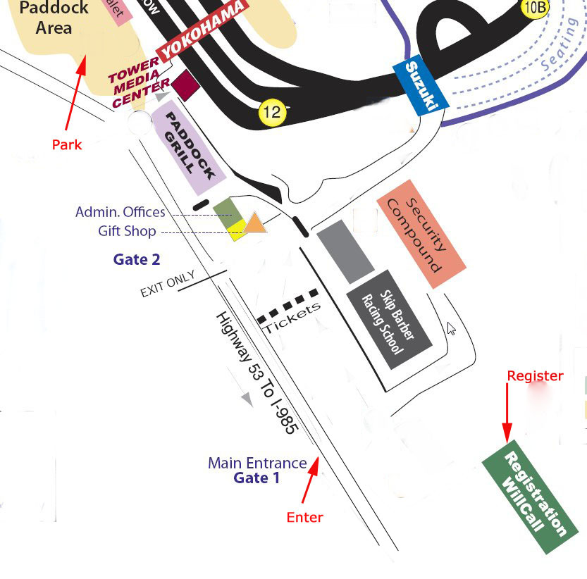

## Entering the Paddock

Enter the track paddock area and find a parking place. Just look where other cars are parked. Leave adequate room around the cars to allow for trailer loading, belongings on the ground etc.

## Preparation for Trackside Tech

Now attend to your car and empty it – empty it of everything. You don’t want that old coke can under the seat rolling under your pedals on the first lap do you? Or that old kids toy on the back seat hitting you the first time you brake hard? Check the trunk(s), the door pockets, glove compartment, remove your radar detector, garage opener, seat covers and any other loose items. Double check under the seats! If you have detachable floor mats they, too, should be removed – both at the front and rear.

Use your duct tape to cover the headlights and fog lights to protect them from any stone chips or debris on the track. Some people also tape the leading edge of the hood and the side view mirrors. You may have a “bra’ on the front of your car for debris protection when on the street. At high speed bra’s can sometimes flap around and actually cause more damage than debris. It is advisable to tape down a loosely fitting or a magnetic bra.

## Car Number

Place your pre-made numbers on both sides of the car, or use masking tape to form your assigned number. Make sure they are as large as possible (and at least 8 inches high and 1 inch wide) so flag marshals can easily identify your car.

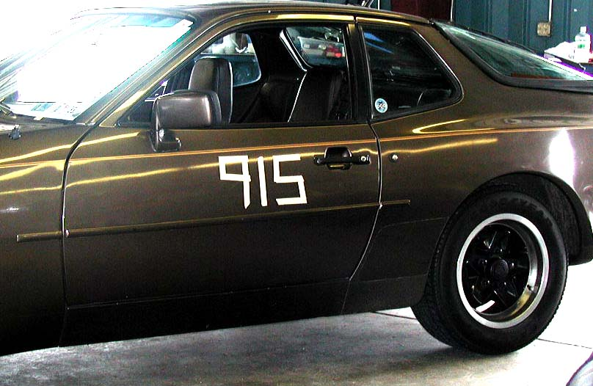

Car numbers must be displayed on the left and right side body panels. The numbers must be in a contrasting color to the body panel color.

## Trackside Safety Inspection “Tech”

Place your pre-event Tech form under the windshield wiper, put your helmet on the passenger seat, leave the trunk and engine lid unlocked and drive slowly to the Tech line. Here the trackside tech inspection crew will greet you, descending on your car to check the torque of your wheel nuts, the state of your brake pads, that your car is empty of junk, that it has its numbers, that you have an appropriate helmet etc. You will probably be asked to use the brake pedal so they can check your brake lights and also ‘blip’ the throttle so they can check the throttle return is working correctly. A small sticker will be placed on your windshield indicating you have passed Tech. Return to your parking place and check that your engine lid and trunk are locked closed.

You only need to present your car to trackside tech on the morning of the first day.

## Rogues Gallery

Have you seen these people? They are not ‘wanted’, but you may well want to meet them, or at least know who they are as they are responsible for the efficient running of the event.

 

First off we have our Track Chair, Mike Wilson and Track Co-chair, Kathy Patton. They are responsible for the overall DE program from A to Z. You will often see them busily attending to all manner of details to ensure the smooth running of the event.

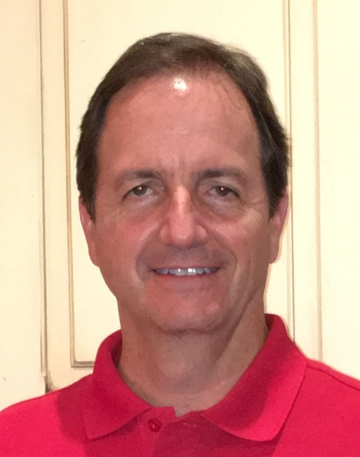

Last, but by no means least, our Chief Driving Instructor – Ed Moulton. Ed looks after all aspects of your training and is responsible for your instructor assignment. If you have questions about the instruction arrangements find Ed and talk to him.

## Drivers Meeting

You may have a few minutes to spare to have a quick breakfast, but check your timetable for the Drivers Meeting. Don't be late – it is embarrassing to have 100+ pairs of eyes on you as you stroll up late! All drivers gather and you will be told about the track, any special conditions on the day, the location of the passing zones, how the flags are to be used, etc.

At Peachstate events, instructors and students are paired prior to the event. The type of car you drive is also taken into account and efforts are made to pair you with an instructor familiar with your type of car. At the end of the Driver Meeting, instructor and student names are called and you’ll get to meet your instructor.

## Track Familiarization

Run Group 1 and any other drivers not familiar with Road Atlanta have an opportunity, first thing on Saturday morning, to make several laps of the track to become familiar with the layout. The laps are made behind a pace car at around 55mph so helmets are not required for this exercise, and your instructor you’ve just met at the drivers meeting will accompany you. Of course you will have worn out YouTube watching laps of Road Atlanta to learn the track layout, but it will seem quite different when driving yourself.

## Classroom Sessions

You will have a couple of classroom sessions where a senior instructor will talk you through the theory you will be (or have been) practicing. The location of the classroom is given at the Drivers Meeting. Please ensure you are on time for these sessions.

## Evaluation Forms

You will be given two forms, a student evaluation (to be filled in by your instructor at the end of the day) and an instructor evaluation for you to evaluate the performance of your instructor. You and your instructors will be able to record your progress as you do DE events and as you progress to “going solo”. The entries will also assist your instructor(s) at subsequent events in understanding your progress thus far. It is your responsibility to ensure that your student evaluation is filled in at the end of each event by your Instructor.

## Preparation For Driving

Let’s now go through some topics in preparation for actually getting on the track.

### Clothing

You have, of course, read the pre-event preparation section so will have brought the correct clothing ☺. Peachstate suggests that you wear a long-sleeved shirt and long pants made of natural fiber. Shoes should have a thin, flat sole with adequate grip so they don’t slip off the pedals. Worn sneakers or ‘boat’ shoes work well for many drivers. Thick-soled shoes are not recommended. You ‘communicate’ with your car through the seat of your pants, your hands and the soles of your feet. You’ll get messages from your Porsche more easily if your feet are not insulated from the car by big thick soles. Leather–soled shoes tend to be too slippery and are not recommended.

### The Weather

Take account of the weather: If it is hot and sunny, as it invariably is at Peachstate events ☺, apply your sun protection now, before you get sunburned. Even more importantly, you need to keep yourself properly hydrated throughout the day. By the time you feel thirsty your body is already dehydrated and this can seriously impair your judgment and safety on the track. Remember to keep drinking liquid, even when you don’t actually feel thirsty. This cannot be stressed highly enough.

There are still a couple more items that need attention before you get on the track. Depending on your schedule, you may want to do these earlier, as you prepare the car for trackside inspection.

### Seating Position

The seat position you use for DE is unlikely to be the same as you use on the street. The majority of drivers position themselves too far back or with the seatback inclined too much. Do not imitate what you see on TV with either the NASCAR driver’s position, upright and close to the wheel, or the F1 drivers who appear laid back with outstretched arms.

The correct seating position takes into account how you contact the seat, leg position and arm position. In order to get better leverage on the steering wheel and in order to get a better "seat-of-the-pants" feel of the car, it is usual to sit a little further forward and more upright, and perhaps a little lower than you may do for street driving. Try following the recommendations below.

Depending on your height (with your helmet on) and whether the car has a sunroof or not, you may find it necessary to lower the seat.

Sit in the seat by pressing into it so that you maximize your body area in firm contact with the car. Pressing down snugly will help you to feel the car communicating with you. Your back should be flat against the seat back, you backside firmly wedged in the right-angle between seat back and seat cushion and the underside of your legs should be in contact with the seat. Put on your seat belt and ensure it is a tight fit - you don't want to be sliding around the seat at the first sharp corner.

Adjust the forward/rearward position of the seat so that you can move your feet easily between the pedals with clearance under the steering wheel. There should be a moderate bend at the knees when you fully depress the pedals with the ball of your foot (not the toes).

Adjust the seatback angle so that with your arms extended and without pulling your shoulders away from the seat, your wrists should be able to rest on top (12 o'clock position) of the steering wheel. Your arms should be bent when your hands are placed on the steering wheel at the three o'clock and nine o'clock positions. This slight bend in your arms, even when being fully outstretched during

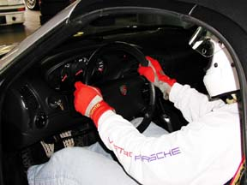

cornering, helps prevent the arms from getting tired through over-extension. This same position should also and allow you to change gears without needing to lean forward.

Your seating position can best be tried in advance of the event.

### Mirror Adjustment

Having, probably, changed your seating position, you now need to adjust all your mirrors to ensure they cover their areas properly.

### Windows & Sunroof

The driver’s side window and the passenger side window must be all the way down. This is for safety purposes so track Corner Workers can easily access the occupants in the event of an incident.

Your sunroof must be closed while on the track.

### Tire Pressure

With the tires cold in the early morning, check the tire pressures all round. As a starting point ensure they are set to the recommended values given in the car’s handbook. Air is available – just ask where it is.

### Staging

“Staging” is designed to minimize the time between run groups by ensuring that the next group of cars is ready to get on the track as soon as the previous group is off. Cars are staged in the ‘hot pits’ area. There are separate entrance and exit ramps to the hot pits and you need to be sure you use the correct ramp. (The entrance or ‘down ramp’ is right alongside the roofed spectator area.) At the drivers meeting there will have been instructions on how and where to stage. Prepare for your run in good time. Go to the bathroom if you need and ensure you are at the staging point with several minutes to spare. Generally your instructor will meet you at staging, although he/she may have made arrangements to meet you in the paddock area – it tends to depend on their workload and number of other students.

### Communicators

Your instructor may be equipped with a two-way communicator to help in-car communication. He or she will give you an earpiece attached to a boom microphone. Put your helmet on first, then take the earpiece and *gently* insert it inside your helmet between your ear and the helmet padding. The boom microphone will be naturally positioned in front of your mouth. At the end of the run, remove the communicator by grasping the earpiece. Do *not* pull the connecting wire - they do not last long if you do ☹. If your instructor doesn't have a communicator don't worry - you will still be able to hear their comments and instructions.

## It’s All In The Mind

So now you’re ready for your first track sessions…. But as the TV detective Colombo made a habit of saying “Just one more thing, Sir...”

There are (at least) a couple of ways you can approach your first few track events. Let’s call the first the 'male' approach. You’ve figured out a way to get to drive your Porsche on the track, you've only got a handful of sessions and you want to make the most of them. You want to get out there and you do everything you can't do on public roads: pushing the car's limits as much as you can, trying to squeeze every tenth of a second out of it that you can -- full on the gas; full on the brakes; catch that guy in front etc. etc. On your first day at DE, a guy can't help but think (however irrationally) that he's going to be the best and bravest driver out there like a Schumacher or Senna in the rough, so to speak.

This is fine and may be a lot of fun, but it will only get you so far. It's like trying to lift the absolute maximum weight you can manage on your first trip to the gym, and then calling that a workout. It's utilizing the perpetually-12-year-old part of your brain. Before too long, you'll have ‘pushed' the car as hard as it will go, and -- what the heck? -- guys in lower-powered cars are still overtaking you. You walk away scratching your head, or writing a big check for an engine upgrade.

Or... you stumble on the second way of approaching a Driver Ed event; Let’s call this the 'female' way, since women are often better learners at performance driving. It's linked to the 'you'd go a lot faster, if you'd just learn to slow down' school of thought which experienced drivers will be able to tell you about.

The smarter way of approaching a Driver Ed event in your first season is to leave your ego in the paddock and see what you can learn from your instructor - your mind as a blank slate, open to listening and learning. Learning the best possible line through each turn - long before you're carrying the maximum amount of speed through each turn - and getting a sense of the subtler relationship between driver inputs and the way the car reacts. It's a slow process. And you've got to accept the fact that the faster guys are faster because they've been doing it longer, and have taken the time to figure out the less fun parts of the equation. Beginners always try to sort out the difference between fast and slow lap times based on the specifications of the cars involved. It's the Viper mindset. The more experienced guys know that horsepower doesn't matter very much -- that 90% of the journey is learning how to drive, and the other 10% is about having a fast car.

Hopefully, you’ll soon realize that you're just starting out and there’s going to be a long and fun road before you.

## On the track

It's quite simple really: Remember "Asphalt - good, Grass - bad" ☺ Seriously though, remember the aims of DE (learning about your Porsche and yourself and having fun), listen to and obey your instructor and enjoy yourself.

As this guide has tried to emphasize, the better you are prepared the more you will enjoy the experience. There are many books and articles as well as Internet sites that explain the principles of performance driving. Some are listed in the Resources section and the end of this document. If you have the opportunity, you are recommended to read some of these.

### Flag Signals

It’s no use cresting a hill, wondering why the flag marshal was waving a yellow flag! By the time you see the car stopped in the middle of the track just over the brow of the hill it will be too late ☹

Understanding the flags and knowing what action to take when you see one is vital. Please take a few minutes now to read Chapter 11 now, test yourself on the flags for a few minutes and then return here. As it says there: **Read, Understand and Memorize.**

### Passing Zones

You are only permitted to overtake or be overtaken in designated passing zones, generally the long straightaways. Higher run groups are permitted to pass in additional areas. At the drivers meeting you will be informed where the passing zones are.

Generally, the car doing the overtaking must move off the ‘line’, with the passed car maintaining the driving line. Don’t feel pressured into giving a passing signal when you are not ready – for example, after a turn, make sure you track out correctly before giving a passing signal.

### Overtaking Signals

In DE events it is not permitted to pass a car without receiving a hand signal from the driver being overtaken and only so long as the pass is made within a designated ‘passing zone’. You’ll learn where the passing zones are located in your classroom sessions. This rule applies equally in *all* run groups. The signals are as follows:

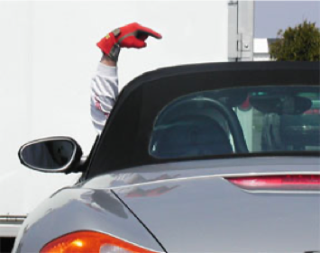

"Overtake me on the right" - point your left arm over the roof of the car

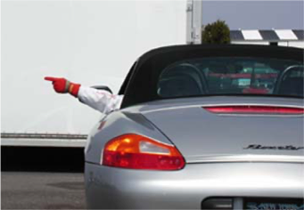

"Overtake me on the left" - point your left arm straight out of the window

Each of these signals indicates to a *single* car behind you that they may overtake. If there are more cars behind, wait until the first car is starting its overtaking maneuver, then give the same signal for each subsequent car. You may need to back off the gas momentarily to allow a safe pass.

If the car in front of you signals you to overtake, it is your decision as to whether to take the opportunity. You are not obliged to pass and you should not pass if you feel at all uncomfortable - for example, you may be nearing the end of the passing zone on the straightaway.

### End Of Run

At the end of your run you will see the checkered flag. Slow down (but not to a crawl) and use your brakes as little as possible to allow them to cool during the remainder of the ‘cool-down’ lap. Keep your concentration up, even on the cool-down lap and continue to drive the correct line. Approaching the pit in turn-off clench your fist and hold your left arm straight up, out of the left window to indicate you are pitting. Use this signal if you need to pit-in during a run as well.

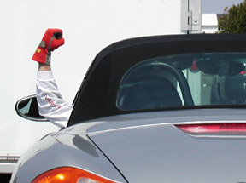

The “pit in” signal

Drive back to your parking spot, still trying to use the brakes as little as possible. The rotors will be very hot and you want to avoid transferring this heat to the brake fluid in the calipers. When you stop and switch off the engine leave the car in gear to prevent it moving. **Do *not* engage the parking brake**. Your instructor will often want to sit with you for a couple of minutes to discuss the run.

### Condition of your car

After a run it is wise to check your car in preparation for your next outing.

* Tire wear - Check your tires after every session for nicks, punctures, or worn areas. If in doubt, show the area to your instructor and ask their advice.
* Tire pressure - Check tire pressure before each session. Tires typically increase more than 5 PSI during track sessions so if you tires have increased pressure this is normal.
* Oil level and temperature - Check the oil level every couple of sessions and add oil if needed. Get in the habit of checking the oil gauge on the track and monitoring oil temperature.
* Coolant temperature - As with oil, monitor your coolant temperature regularly while on the track. If you get a reading in the red zone or no reading (too little coolant), you should end your session early and let things cool down.
* Fuel level - You’ll be surprised at how quickly you can go through gas. If you’re not sure whether you have enough to make it through an entire session, get more gas. You don’t want to take up everybody’s track time getting towed off the track. There is a Chevron station less than a mile from the track (South on SR53). Road Atlanta has gas pumps on site with race fuel as well. You must have a credit card with US billing address to use their pumps.
* Brakes – Track driving takes its toll on the brakes. You may have an indicator light that warns you when the brake pads are getting thin, but if your car doesn’t have one, you should learn to examine the brake pads yourself. Ask someone to help – they’ll be only too willing to show you how. While driving, if ever the brake pedal starts to feel soft or spongy, tell your instructor and come into the pits immediately. A soft brake pedal happens shortly before the pedal goes straight to the floor without any resistance – not a fun experience. This happens when your brake fluid boils and can be easily rectified by “bleeding” your brakes. This is a simple process – again, ask someone for help if you need to do this.
* Get into the habit of checking your lug nut torque – say every couple of sessions. The expansion/contraction heat cycling can cause the nuts to work loose. If you don’t have a torque wrench, borrowing one from a fellow driver is a great way to meet your fellow drivers. Just make sure you return it when you’re finished!

### Your condition

Are you sweating after your run? Don’t forget to keep properly hydrated! Drink a little, often.

# Miscellaneous Tips

The following sections are an accumulation of distilled knowledge that didn't belong in prior sections. They are however, valuable tid-bits that may prove useful to you at some stage in your DE career.

## Your Well-Being

At summer events you need to be aware of the effect of heat and sun on your body and take measures to cope. The tips below may sound like common sense, but are important; People have been known to collapse from heat exhaustion and, even in less serious cases, unfortunately, your judgment is one of your first faculties to suffer through dehydration.

* Apply sunscreen liberally.
* Wear a hat while in the paddock
* As stressed earlier, dehydration leads to deterioration in judgment, concentration and mental performance**. Medical studies have shown that fluid loss exceeding approx. 3% of bodyweight impairs reaction time, judgment, concentration and decision making**.

Says Glen Lindsay, a physiotherapist with the Jordan F1 team: …”And if you a think a driver can rely purely on his own body to tell him when to drink, you would be very much mistaken. “On race day I encourage drivers to drink little and often, monitoring their hydration levels regularly,” said Lindsay. “In fact feeling thirsty is not the best indicator because by the time you experience thirst, the body is already dehydrated. Basically it's my job to keep a drink bottle in the drivers' faces at all times”

Drink 16-32 ounces of cool fluids each hour, even if you're not thirsty; thirst is NOT an accurate indication of dehydration.

* Be alert and if you notice any of these symptoms of heat exhaustion pull off the track and let someone know: Dizziness, Headache, Heavy sweating, Muscle cramps, Nausea, Weakness.

## Lug Nuts

For those of you who change tires at the track: Most early Porsches have light, aluminum alloy lug nuts. Along with the wheel, these lug nuts will get hot during your run. Do not try and remove them when hot. If you try and remove them with the commonly used soft-socket-with-a-plastic insert (to prevent damage) the plastic may turn to a gooey mess. If you use a regular steel socket it is easy to break the neck of the lug nut from the collar. Removal of such a destroyed lug nut is not generally something that can be done at trackside and you’ll be on an early journey home!

Wait for the lug nuts and wheel to cool, or alternatively use open, steel lug nuts.

Although later Porsches like the 996, 997 and Boxster utilize steel lug bolts, it’s still advisable to allow the wheels to cool somewhat before attempting to remove them while very hot.

## Engine Coolant

The “Water Wetter” product is popular with frequent track goers to hot Road Atlanta. It can reduce your coolant temperature by 10 degrees or more and may be worth considering if you notice your coolant temps getting too close to the red zone. Regardless, be sure to monitor coolant levels in case you lose coolant via the overflow.

## Sneaker Whitener

You’ll often see recommendations to write your car number on the body or windows using sneaker whitener. Treat such recommendations with a pinch of salt. First of all, if it rains you’ll have a runny mess on the car. Secondly, when you subsequently rub the sneaker whitener off with towels and window cleaner, any specs that get on the bodywork (and they will) are very difficult to remove! Use masking tape to form your car numbers or get a waterproof Liquid Chalk marker pen.

## Removable Car Numbers

Once you have made a commitment to do several DE events, you may want to consider getting you assigned car number made up on a removable decal. Numbers should be at least 8 inches high. You may choose numbers made from magnetic material, or vinyl numbers stuck on to a magnetic background circle. Remember that a magnetic decal may come unstuck at high speeds. It is therefore recommended to use some masking tape to secure the leading edge of the decal. This is especially true for magnetic panel numbers; less of a problem for individual magnetic numbers.

## Keys in Car

Leaving your car keys in the car while you are away from it is a personal choice, but bear in mind that in the event of a sudden summer thundershower while you are away from the car, a helpful colleague may be able to get your windows and sunroof closed and save your interior from a drenching.

# Safety And Performance Modifications

The following topics are not a concern for the beginner driver. Once you have several events under your belt you may want to consider some of the changes mentioned below. The paragraphs below are placed in no particular order.

## Harness, Seat and Roll Bar/Cage

These three topics are all covered here because current thinking considers them all as part of a single safety system. The PCA mandates that a harness may not be used without seats designed to accommodate them, and if you do have an appropriate seat and harness, a roll bar or roll cage is recommended to complete the safety system.

Once you have done a few events and your cornering speeds increase, you may find yourself bracing yourself against parts of the car. The stock seat belts are good, but cornering and braking from high speed ideally calls for a harness to keep you firmly in your seat. Most popular nowadays are 5 or 6-point harnesses. A 4-point harness is not safe and they are no longer permitted by PCA. If installing a harness, ensure you install it for the passenger too. PCA requires the same restraint system for both occupants. After all, if it's good enough for you it should be good enough for your instructor ☺.

PCA requires that all cars equipped with a 5 or 6-point safety harness must have appropriate seats that provide routing holes for the shoulder straps and the anti-submarine strap. All pieces of the restraint system must be installed in accordance with the manufacturer’s instructions.

Race seats have the required routing holes for the harness, provide more support when cornering and may be lighter, saving some weight compared to the stock seats. However, they may not be so comfortable for those long drives on the street. Other drivers will be happy to discuss their choice of seat with you and allow you to see how you’ll ’fit’ in their car.

The likelihood of a rollover accident is very small but it can happen; If you have installed seats and harnesses, you will be firmly strapped in your seat and may find it difficult to bend out of the way of the roof. While the roof pillars on your Porsche are very strong, a roll bar or roll cage may be installed for extra safety. A roll bar is typically a steel hoop bolted or welded to the body and extending above and behind the driver. These are often welded in place, although some models are “bolt-in” and can be removed if, for example, the car is sold. The roll bar should be properly padded. A roll cage extends the roll bar along the roofline, down the windscreen pillars and usually anchoring on the front door sills. Roll cages are primarily intended for dedicated race cars and are not generally used in street cars because of the difficulty of getting in and out of the car and the fact that unless strapped in with the racing harness, there is the chance of hitting the steel tubing in the event of a street accident.

***Tires***Good quality street tires are entirely adequate during your first several events. Without any track experience, you won't be using any tires to their performance limits. Learning the feel of your car through street tires aids learning and will teach you how the car feels and behaves as you approach the limits of adhesion. Also, starting out with your car in stock configuration will give you a baseline for comparison so that once you get some track experience you will be better able to judge the impact of a tire upgrade on your performance. Any of the Z-rated street tires give you very good performance on the track and it works out less expensive because they wear so much less than track tires. (You won't go through a set of street tires in a track weekend!).

As you become more experienced, you may want to try tires with higher performance (more grip). If your car is also used on the street you have a few choices; you can fit high performance street tires, you can fit R-compound track tires that are street legal (but which wear more quickly than street tires), or you could get a second set of rims and fit dedicated track tires (slicks). As you attend more DE events ask plenty of questions and make your own decisions.

## Brake Pads

Stock Porsche brake pads work well on the street but for most cars they are not optimized for the heavy braking you will be doing at the track. After several events, as your speed increases, you may find that you want to try a pad more suited to the track. Several upgrade options are available – from out-and-out race pads to ones suitable for mixed track/street driving. In general, track pads need to be hotter to get maximum braking effect, which is why they may not be completely effective on the street on a cold winter morning. They will also tend to be tougher on the rotors than stock brake pads.

Changing pads is such a simple job it is practical to have one set for street and a second set for the track.

## Brake Fluid

Brake fluid is a hydraulic fluid used to transfer pressure on the brake pedal into the clamping action of the brake pads onto the rotors. Driving at the track causes brakes to get very hot. Some of the heat is dissipated by the large metal mass of rotors, some is dissipated by the airflow over the rotors, but some heat is transferred through the brake pads to the calipers and the brake fluid in the calipers. Unfortunately, brake fluid absorbs water from the atmosphere (in technical terms it is “hydroscopic”) and the longer it has been in your brake system, the more water it will have absorbed. Brake fluid has a very high boiling point (often over 400 °F) but water doesn’t. If the heat transferred to the fluid causes any water in the fluid to boil, steam is generated and air bubbles form in the brake fluid. Brake fluid is not compressible (that’s why it’s used) but air bubbles are. The end result is that the brake pedal will start to get “soft” and will eventually go to the floor with no braking power at all. (If ever you feel your brake pedal going soft, slow down, pump the pedal a few times to get full braking effect back and pull in at the pits as soon as possible.)

If you become a DE regular, change your brake fluid for each event and use a high-quality, high boiling-point brake fluid.

## Brake Rotors

A word of warning about aftermarket cross-drilled rotors: They may look good, but the process of drilling the holes inevitably leads to increased areas of stress and to cracks, radiating from the holes. If not monitored very closely these cracks can, within a few track sessions, radiate through the rotor and become potentially dangerous, leading to a rotor failure. Note that Porsche factory rotors are cast with the holes, rather than drilled and this is much, much better at resisting cracks. The original reason for drilling rotors was that compounds in early brake pads would ‘out-gas’, forming a boundary layer of gas between the pads and rotors and making for poor braking. The holes allow the gas to escape and restore braking performance. Modern pad compounds rarely out-gas, so the utility of drilled rotors is nowadays limited to marginal extra performance in very wet conditions when water can form a boundary layer. Compared to the risks of a broken rotor when used on the track, consider carefully the choice of aftermarket cross-drilled rotors.

## Driving Shoes

Purpose designed and made for performance driving, although they may still be worn around the paddock, they provide excellent ‘feel’ through the soles.

## Driving Gloves

Driving gloves serve mainly to allow you to keep a good grip on the wheel. Good gloves, typically with leather on the palm and fingers, give you a good feel on the steering wheel while also absorbing the sweat from your hands. Choose a contrasting color to your car to help other drivers see your passing signals.

## Driving Suit

Primarily of utility to those drivers taking part in Porsche Club Racing, a good quality driving suit can provide several seconds of protection to the driver in the very unlikely event of a fire inside the car. Think of it as extra insurance! The more expensive suits are made from an inherently fire-resistant material, (Nomex, Kevlar, PBI), while cheaper ones are made from treated cotton fabric (Proban, Fireware). Generally speaking, the more layers of material, the greater protection is offered, but the hotter you will be when wearing it. Besides the fire-resistance of the material itself, the air gap between the layers is also important.

If you go down this route, remember that the driving suit is just one item used for total body protection. The other items include: helmet, head sock (balaclava), helmet skirt, HANS device, gloves, underwear, socks, and shoes. All these items must work together to achieve total protection. If any one part is inadequate or fails, it will undermine the effectiveness of the whole.

## Head and Neck Support device (HANS)

You may see some drivers wearing an odd-shaped contraption attached to their helmets and extending down over their shoulders. This is a ‘HANS’ device, designed to stop the head from whipping forward in a crash. Mandated by many race series, these safety devices are now within the budgetary reach of DE enthusiasts. With the high performance now available from modern Porsches, drivers who make a commitment to DE would be advised to consider a HANS device, although it should be noted that these devices will generally require replacement of the original seats and seat belts in your Porsche.

# Resources

Where local resources are available these are mentioned.

## Car Numbers

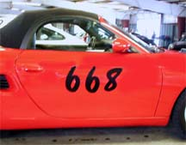

A local sign shop may be able to help you.

Discovery Parts will prepare numbers for you.

[www.clubregistration.net](http://www.clubregistration.net) also offers both adhesive and magnetic numbers

## Helmets

For helmets and other driving apparel and accessories try NaroEscape Motorsports, one of our local sponsors, at <https://naroescapemotorsports.com> NaroEscape Motorsports frequently attend Peachstate DE events. If it’s a bit close to an event to allow for shipping, you can order online from them and pick the items up at the track.

## Internet

On the Internet there are a plethora of sites dedicated to Porsches. A small selection follows:

<http://www.peachstatepca.org> - Your own club website. Check it periodically for updates

[www.rennlist.com](http://www.rennlist.com) - The premier Internet resource for the Porsche enthusiast

[www.pca.org](http://www.pca.org) - The Porsche Club of America site. It has useful links to websites of all other clubs and regions.

<http://forums.pelicanparts.com/index.php> – The Pelican Parts technical forums are another great resource.

Your copy of ***Peachstate Presse*** contains useful advertisementsand articles.

## Performance Driving Books and Articles

(In no particular order)

* Secrets of Solo Racing by Henry Watts
* Driving in Competition by Alan Johnson
* Going Faster by Carl Lopez/Skip Barber Racing School
* Porsche High Performance Driving Handbook by Vic Elford
* Speed Secrets – Professional Race Drive Techniques by Ross Bentley

## DE Insurance Resources

[Locton Affinity (via PCA)](https://www.pca.org/hpde-and-track-insurance-1)

[Ontrackinsurance](https://ontrackinsurance.com/index6.aspx)

# Flag Descriptions - READ...UNDERSTAND...AND MEMORIZE

If you are viewing this on a screen or have a color printer the flags below are shown in glorious Technicolor. If you have a black and white printer, just use your imagination ☺

|  |  |
| --- | --- |
|  | A GREEN flag indicates a clear track and you can proceed at speed. |
| red | A waving **RED** flag is an indication of a serious problem on the track and that the run group is ended *immediately*. Pull off the line to the side of the track (stay on the pavement) and **STOP** immediately in a safe manner, within sight of a flag station. Remember to check your rearview mirror before braking to a stop; Someone behind you may not have seen the flag!  Do not proceed back to the pits. Remain in your car, leave your engine running, and be prepared to proceed once the black or yellow flag is presented. A black flag after a red flag indicates to all drivers to proceed at reduced speed to the pits. A yellow flag following a red flag indicates to all drivers that they may proceed at a reduced speed with no overtaking until given the all clear to continue at speed. |
| black | A **BLACK** flag is a signal to **PULL INTO THE PITS**. It may be used to bring all cars in the session to the pits, or it may be used to signal an individual driver to come to the pits. In either case, pull into the pits, giving the pit-in signal.  When used to warn a particular driver, the flagger on the Start/Finish line or at the Black Flag Station will point the Black Flag to the car being flagged as it passes the station. In addition, the car # may be displayed at the Black Flag Station. The driver should acknowledge the Black Flag with a hand signal and proceed at reduced speed, with caution, to the pits where they will report to the Pit Marshal. The Black Flag may indicate either mechanical trouble or incorrect driving behavior.  When used to bring all cars to the pits it will be displayed in the standing position at the Start/Finish line and at the Black Flag Station and may be displayed with a sign ALL. All cars will proceed at a reduced speed to the pits and follow the instructions of the Pit Marshal. |
| yellow | **STANDING YELLOW:** Slow down (but do not jam on the brakes). There is a problem on the track ahead requiring **CAUTION** in the vicinity of the flag, such as a car off the road, an animal on the track, etc. **NO PASSING.** |
| yellow | **WAVING** **YELLOW:** There is a problem in the immediate vicinity. Proceed with **EXTREME CAUTION** and be prepared to stop. **NO PASSING.** |
| yelo-red | **YELLOW** with **RED STRIPES** indicate a **SLIPPERY** or **HAZARDOUS** track. There is something on the track causing a slippery condition. It may be oil, water, debris, dirt etc. on the track. Drive with **CAUTION**. Remember, once you have seen this flag, the track is likely to remain slippery at this place on future laps – even if the flag is no longer displayed. |
|  | The “**Meatball**” flag indicates there is something mechanically wrong with your car. Proceed to pit lane immediately and consult with Pit Out Marshall or steward. |
|  | The **WHITE** flag means that there is a **SLOW-MOVING** or **EMERGENCY VEHICLE** on the track ahead of you. Treat this flag as a yellow flag. **NO PASSING**. Reduce speed and proceed with **CAUTION.** |
| blu-yelo | **BLUE or BLUE with a YELLOW STRIPE:** The flaggers have noticed a faster car behind you. **CHECK YOUR REAR VIEW MIRROR**.Allow them to pass at the next passing zone by giving the appropriate signal. |
| checker | The **CHECKERED** flag means the **END OF THE SESSION**. Displayed at the finish line. Finish the lap at cool-down speed, then pull into the pits, giving the pit-in signal. Do not pass after the checkered flag. |

# Run Groups and Advancement Policy

Below are Peachstate Region PCA guidelines for skill levels expected in DE Run Groups. These are the levels of accomplishment and required skills that must be demonstrated to an instructor before being promoted to a higher Run Group. It should be understood that drivers within each run group will be at varying levels of achievement.

Instructor sign-offs for run group promotions can occur in several ways. First, a student may request an evaluation review of their skills from their instructor (or from the Chief Instructor if already signed-off in an upper level and requesting to move to a higher group). Alternatively, an instructor can recommend a sign-off for promotion, generally after discussion with the driver. The instructor would indicate this recommendation for advancement on the Student Evaluation Form. Upper-level advancements require both a consultation with the chief instructor and a written evaluation by a check-out instructor.

A newly signed-off solo student driver will remain in their original run group for the remainder of that event, using an “S” decal to designate the sign-off, but depending on the circumstances, that student may or may not be promoted to the next level at the next event. Changes between run groups during an event are generally not possible, but in exceptional circumstances, arrangements may be made.

## Group 1

Peachstate policy is that Group 1 students signed-off (for a day or a session) do not automatically progress to Group 2, or cease to require an instructor. Students will be promoted to Group 2 when they meet the written criteria below, and can expect continued instruction in Group 2 as part of Peachstate's instructional program. The goal of Driver's Education is to assist each driver in learning and improving their skill level to the best of their ability. Students can expect to spend at least three or four events in the Group 1 run group with an instructor. As drivers gain experience in Group 1, they are expected to polish their high performance driving skills, increase their confidence, and learn more advanced techniques. Promotion to Solo status requires a positive recommendation from a Peachstate instructor plus approval by the Chief Driving Instructor.

* Drives the line consistently and correctly (with no help for one session).
* Drives at an appropriate pace with the group.
* Consistently uses very smooth inputs, with special emphasis on proper, smooth braking.
* Uses "ocular vision" techniques (looking ahead) in most corners.
* Makes only a few minor mistakes, but self-corrects.
* Remains calm in traffic and in passing situations.
* Anticipates the effects of a slower car ahead.
* Does not follow too closely when far from a passing zone.
* Neither gives nor accepts late passing signals.
* Gives passing signals promptly without being reminded.
* Passes with good safety margin distance.
* Exhibits good manners and shows consideration for other drivers.
* Displays full knowledge of procedures, flags and driving terminology.
* Establishes a good and safe driving record for two events, minimum.
* Calmly deals with faster traffic and close passing situations.
* Demonstrates full compliance with Peachstate Region DE safety and driving philosophy.

## Group 2

The Group 2 run group is a "Solo-only" (no instructor required, but may be requested) group. Group 2 drivers are characterized by a wide range of skills and experience, as drivers gain seat-time and work on advancing their driving skills. These drivers will be working toward improved consistency, use of vision, and the use of momentum. The skills listed below assume proficiency in the skills listed above for Groups 1. A student can expect to spend at least one active season in Group 2.

* Drives the preferred line consistently and effortlessly.
* Uses "ocular vision" (looking ahead) techniques most of the time.
* Consistently uses very smooth inputs both at medium and higher speeds.
* Uses and can demonstrate trail braking, throttle steer, and heel-and-toe techniques.
* Carries considerable momentum through corners.
* Can safely vary the line in any corner (to avoid debris, for example).
* Calmly deals with cars in close proximity.
* Drives at a pace appropriate for the run group and approaching the limitations of their car.
* Displays a courteous, respectful attitude, avoiding intimidation and overly-aggressive behavior.

## Group 3 (Advanced and Instructors)

Promotion to Group 3 requires a positive recommendation from a Peachstate Instructor and approval by the Chief Driving Instructor. Drivers in Group 3 are expected to be expert in all the driving skills taught by Peachstate. The experienced Group 3 driver should be indistinguishable from the average driver in Group 4. Many Group 3 drivers are, in fact, Peachstate Instructors or expert drivers who prefer to stay in Group 3 due to their car's top speed and/or horsepower.

## Group 4 (Expert and Instructors)

Group 4 consists of the most experienced drivers in the fastest, highest horsepower cars. Group 4 drivers are experts in all driving skills taught by Peachstate and PCA at large. Many drivers in Group 4 are instructors and/or hold Porsche Club Racing licenses. In recent years, Peachstate has attempted to balance groups 3 and 4 based on a combination of driver skill and the top speed and horsepower of a driver's car. We have found that this policy helps maintain the balance of the group as a whole and has reduced the tendency of lower horsepower cars to hold up long lines of faster cars waiting for a passing signal.

# Personal Checklist

Please feel free to print copies of this for future use

|  |  |
| --- | --- |
| **PACKED** | **ITEM** |
|  | Driver's license and PCA membership card |
|  | Completed Tech Inspection Form |
|  | Maps and Directions to the track and hotel |
|  | Paper towels |
|  | Window glass cleaner |
|  | Paper towels |
|  | Tire pressure gauge |
|  | Duct tape and a knife |
|  | Car numbers or materials for making them |
|  | Quart of oil & funnel |
|  | White shoe polish / sneaker whitener |
|  | Plastic bags |
|  | A tarpaulin or large garbage sacks |
|  | Helmet |
|  | Sun protection: sunscreen and a sun hat |
|  | Umbrella |
|  | Folding chair |
|  | Driving clothing |
|  | Non-Driving clothing |
|  | Cooler with drinks and ice |
|  | Food & snacks |

# Driving Directions and Local Hotels

## From I-85

* Take I-85 to Exit 129
* Go West on Highway 53 approximately 5.5 miles
* Road Atlanta is on the left

## From I-985

* Take Exit 16 to 53 E
* Drive approximately 6 miles
* Road Atlanta is on the right

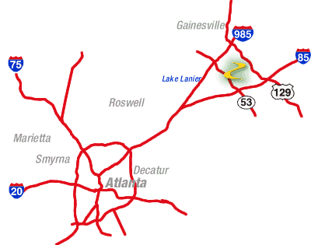

## Local Hotels

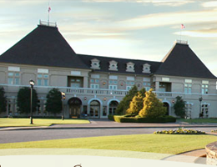**The Inn at Chateau Elan**  
A four-star resort and conference center that  features 276 French-style deluxe guest rooms, and amenities including spa, golf, tennis and winery tours.  Located at exit 126 on I-85, 5 miles from Road Atlanta. Reservations: 678-425-0900 or 1-800-233-WINE. [www.chateauelan.com](http://www.chateauelan.com)

**The Holiday Inn Express at Chateau Elan**  
This 80 room limited-service hotel is across the street from Chateau Elan.   
Reservations 770-867-8100. [Website](https://www.ihg.com/holidayinnexpress/hotels/us/en/braselton/bsega/hoteldetail)

**Oakwood Area**

**Country Inn and Suites** 770-271-1441 [Website](https://www.radissonhotelsamericas.com/en-us/hotels/country-inn-braselton-ga)

**Best Western Plus** (855) 516-1090 [Website](https://www.reservations.com/hotel/best-western-plus-lake-lanier?rmcid=tophotels4&utm_source=bing&msclkid=d9e8357a19f9101e6dc055bf2674df52&utm_medium=cpc&utm_campaign=Top%20Hotels%204&utm_term=The%20Best%20Western%20Oak%20Wood%20GA&utm_content=BEST%20WESTERN%20PLUS%20LAKE%20LANIER_1728526)

**Quality Inn** (770) 287-1000 (When reserving for an event, ask for the Porsche Club discount) [Website](https://www.choicehotels.com/georgia/oakwood/quality-inn-hotels/ga124)

Additional hotel information may also be found on the [Road Atlanta](https://www.roadatlanta.com/fan-guide/accommodations) site.

**Mall of Georgia Area**

Your spouse is not interested in DE? Maybe a stay in the **Mall Of Georgia area** will fit the bill? The hotels are a bit more upmarket than in Oakwood and the shopping is close at hand.

**Marriott Springhill Suites**. 678-714-2150 [Website](http://www.marriott.com/hotels/travel/atlbf-springhill-suites-atlanta-buford-mall-of-georgia/)

**Hampton Inn** 678-546-1200 [Website](https://www.hilton.com/en/hotels/atlmghx-hampton-atlanta-mall-of-georgia/)

**Lake Lanier Area**

With your Family? You may want to consider

**Lake Lanier Islands Resort Legacy Lodge & Conference Center**

Set on the picturesque shores of Lake Sidney Lanier is Lake Lanier Islands Resort – Georgia’s most visited lakeside resort destination. The 1,100-acre resort boasts a variety of amenities and attractions including the 287-room Legacy Lodge & Conference Center, including 30 New England-style Lake houses at Legacy and six executive lakeside Legacy Villas, 18-holes of championship golf, the lake’s largest fleet of rental boats at Harbor Landing, a summertime Beach & Waterpark, scenic horseback riding, exquisite spa services and more. 770-945-8787 [Website](https://www.lanierislands.com/lake_lanier_accommodations/legacy_lodge/%20)

# Peachstate PCA Driver Education Event Rules

**This is Driver's Education - not a Racing School.**

To ensure our participant's highest level of safety and fun, the most important rules of our Driver's Education program are:   
  
Rule 1: No Racing   
  
Rule 2: No Racing   
  
Rule 3: No Racing   
  
Rule 4: See Rule #1   
  
**Driver Safety**  
The safety of all our participants is our foremost concern. Therefore, we insist that all rules be followed to ensure a safe, pleasant, uninterrupted learning experience. If you do not conform to the written and verbal rules of this event, you will be not be permitted to drive on the track and asked to leave the event. Additionally, you will forfeit your registration fee - no exceptions. Peachstate Region Porsche Club of America wants all participants to have a safe, rewarding, and enjoyable weekend. Erratic, unsafe, or at-fault driving incidents on the track will not be tolerated, and will serve as grounds for immediate dismissal from the event, plus registration fee forfeiture, at the sole discretion of the Event Chairman

We ask that you pay particular attention to the rules set forth under the Flagging Regulations. All of the material in the [DE Manual](http://www.peachstatepca.org/DriversEd/18) should be reviewed before coming to the track, as there will no time to do so once the event begins.

In case of rain, slow down to a speed below which you know you can drive safely in the wet. Check the condition of your tires and brakes after every session. Check you oil level before every session. Keep an eye on your schedule and always be on time!

Concentrate on being smooth and taking the correct line. Do not focus on improving your speed - instead, focus on improving your consistency and accuracy in driving the racing line, and a commensurate increase in speed will naturally follow.

**Recommendations in Case of Trouble While on the Track**  
If you are about to run off the track surface, it is always best to drive off in a straight line. Do not make a futile attempt to hold the car on the track, as this usually creates a more dangerous situation. If you err in judgment and lose control (i.e. spin), the best rule is: "both feet in" (brake totally depressed, clutch totally depressed) until the car comes to a complete stop.

If you suspect that your car is experiencing mechanical problems while on the track:

* If serious, pull off the track slowly and await assistance from the Corner Workers.
* If you can continue, do so slowly, and return to the pit area. Drive off of the racing line, and use hand signals and flashers to indicate that you have a problem while returning to the pits.

**Convertibles**  
Any make of car delivered with factory installed roll-over protection meets the minimum standards for PCA DE events. In these cars, the soft-top must be placed in the up position, or have the hard top installed. If, however, the restraints have been changed to 5- or 6- point systems, an approved seat and a rollbar meeting the 'broomstick' rule (the driver's helmeted head is below a bar placed atop and across the rollbar and windshield) will be required.

If a car does not have factory installed roll-over protection, a roll bar must be installed, which meets the 'broomstick' rule. All targa tops must be installed unless there is additional roll-over protection in place. All sunroofs must be placed in the closed position. The windshield alone is not considered to be factory roll-over protection.

**Equal Restraints**  
Both student and instructor shall have the same restraint system. All vehicles must be equipped with a properly installed lap and shoulder restraint system.

**Harness Systems**  
If the participant chooses to install a 5- or 6-point driving harness, several changes to the automobile must be made to create a safe occupant restraint system Harnesses must include an antisubmarine strap, and be mounted in an approved manner consistent the manufacturer's instructions. The harness system must be used in conjunction with a seat which has the supplied routing holes for the shoulder and antisubmarine belts. All pieces of the restraint system must be installed in accordance with the manufacturer's instructions.   
  
This means that a seat must have proper routing holes for the harness, as supplied by the seat manufacturer, for the shoulder and anti-submarine straps. The shoulder straps should be mounted at 90 degrees to the axis of your spine, or at most 40 degrees down from horizontal. Because the addition of the harness system means that the occupants are fastened upright in the vehicle, a properly padded roll bar or roll cage is strongly encouraged to complete the system. The use of one without the other may result in an unsafe environment and is not a complete system. Due to ultraviolet light degradation and wear, the harness webbing must be replaced every five years.

4-point systems are not allowed in Porsches because of the integrated headrest supplied by the factory. In addition to the standard SFI and/or FIA approved 5- or 6-point system, a 4-point system is allowed in non-Porsches that meets the following requirements:

1. Meets the Federal Motor Vehicle Safety Standard 209

2. Attaches to the factory seat belt mounting points

3. Each belt is designed to work in a specific vehicle and that vehicle tag must be attached to the belt system

An example of a system that meets the above criteria is the Schroth Quick Fit system.

**Pre-Event Technical Inspection**  
A technical inspection must be completed in writing, usually by a qualified Porsche dealer or service center prior to the event. This inspection is your responsibility and it is for your safety! Please have your car totally prepared for the event on Saturday prior to the driver's meeting, which usually occurs under the chalet in front of the front straight at around 7:30-8AM. For this preparation, remove all loose objects from the trunk and passenger compartment, including the driver's floor mat, have a sufficient amount of gas for the day, properly inflated tires, lug nuts properly tightened, and your car number affixed.

**Onsite** **Technical Inspection**  
Onsite technical inspections ("Tech") are performed Friday evening in the Road Atlanta Tech Shed (located in a white building/garage in the center of the paddock along the front straight of the track) at the time published in the Event Schedule. Tech is also performed Saturday morning at the track from 6:30 AM until 7:30 AM only. If you miss both of these two tech sessions, your car will not be certified as inspected until after the run groups go out on the track and an inspector is available between their own runs. It is imperative that you bring to tech both your Pre-Event Technical Inspection form filled out and signed, along with the Technical Inspection Certification and Indemnity Form. Also, please have your assigned car numbers affixed to your car when presenting it for onsite technical inspection for processing your car as quickly as possible.

**Helmet**  
All drivers are required to have a Snell SA2015 or SA2020 approved helmet for this event. You will not pass onsite technical inspection unless you have a helmet which meets this safety standard - no exception. *Motorcycle or "M" rated helmets are absolutely not permitted.*

**Clothing**  
All drivers are recommended to have proper clothing for track driving. This means:

* Long Sleeved Shirt (Shirt should be made of a non-synthetic fiber)
* Long Pants (Pants should be made of a non-synthetic fiber)
* Leather or natural fabric shoes with rubber/leather soles.
* Alternatively, approved driver's suit and shoes/gloves.

**Car Numbers**  
All drivers are required to display their pre-assigned car number on both sides of their car, in a color which contrasts with the car color so that they can be easily readable from the Road Atlanta Control Tower. (No checkerboard numbers, please.) The numbers must be at least 8 inches high, and 1 inch wide. The numbers must be affixed to the car at the onsite technical inspection. Without numbers, you will not be allowed on the track! If your numbers blow off, you must replace them before going out on the track again. Numbers on the windshield are deemed not acceptable.

**Staging**  
Staging will be in the Pit Lane (the grid area directly in front of the chalet overlooking the front straight) for the next Run Group to be organized and safety-checked before going out on the track. All other cars will be located either on the track or in the Paddock (large parking area).

**Instructors**   
Instructors shall be stationed in Pit Lane near the Hot Pits. For safety purposes, driver changes, instructor pickups and discharges, are to be made only in the Pit Lane, or as noted in the event supplemental regulations.

**Windows**  
For safety purposes in the event of an accident in which driver or passenger access is required by a Corner Worker, all cars are to be driven with the driver and passenger side windows down. Drive with the sunroof closed. Always drive with you and your passenger's hands and arms inside the car, except to give passing signals or to signal your intention to enter pit lane after Turn 10b.

**Entering the Track**  
Pull your car up to the end of Pit Lane. Follow the instructions of the Pit Marshall and stay to the left of the track as you accelerate up to a safe speed. Use your mirrors to see if you are being overtaken before you attempt to leave this lane.

**Passing Rules**  
Passing will be allowed based upon the individual event supplemental regulations. All passing shall be done with the car being overtaken remaining on the racing line. Be sure that you have plenty of time, space and horsepower to complete your passing maneuver. Never pass another car until they give the appropriate clear hand signal allowing a pass.

a) Overtaking Car  
Be sure that you have plenty of time, space, and horsepower to complete your maneuver. Never pass another car until they signal you by! Do not tailgate. Do not group together. If you find yourself too tightly grouped, slow down for a lap and let the pack get away from you. Alternately, come into the pits to give the pack a few moments to get far ahead and then reenter the track with lighter traffic.

b) Overtaken Car  
Watch your mirrors for cars that want to pass. You must signal another car to pass you by pointing over the top of the car or out the window, signalling the side they should pass you on. Do not move off the racing line. Do not try to out-horsepower an overtaking car by accelerating- let them by safely! Do not block faster cars. Do not group together. If you find yourself too tightly grouped, slow down for a lap and let the pack get away from you. Alternately, come into the pits to give the pack a few moments to get far ahead and then reenter the track with lighter traffic.

Failure to comply with the passing rules will result in you being Black Flagged and directed off the track, missing your Run Group track time.

**Two Spin Rule**  
If any driver spins their car, or leaves the track surface with all 4 wheels, on the second incident of spinning, they will be required to leave the track for the remainder of the day. If they spin 3 times over the two-day event, they will be finished for the event.

The procedure will be as follows:

* On the first incident, the entrant will be black-flagged (see Flags) and directed to immediately come into the pits. In the pits, the driver will be counseled and advised that if this happens again, the entrant will be brought off the track and not allowed to drive for the balance of the day. The vehicle will also be inspected for any pebbles or debris that could be deposited on the track and become a safety hazard to other drivers.
* A spin that continues into four wheels off will be considered one incident.
* Any combination of spin or four wheels off in a single day will be considered to be two incidents.
* Any two-wheel off, or half spin, will require a visit to the pits for consultation and vehicle inspection.

**Exiting from the Track**  
To safely signal your desire to exit the track into the pit lane to other drivers, extend your left arm upward, out of the window, in a fist, prior to your exit from the track. At the Road Atlanta Course, the pit road exit begins at turn 11 (The Bridge Turn). The lane is on the left, but is not visible until you have passed under the bridge. Extreme caution should be used in locating the Pit Lane entrance. Once you have completed the 90-degree turn at the bottom of the Pit Lane entrance, you must reduce your speed to 10 mph while in Pit Lane.

# Road Atlanta Rules

* No Firearms or Weapons
* No Pets
* No Fireworks
* Do Not Use The Fences As Stakes For Tents
* No Scaffolding Over 6 Feet High
* NO Camp Fires Permitted
* All Unlicensed Vehicles Must Be Registered
* For Your Safety, No Glass Containers Allowed
* Speed Limit For All Vehicles Is 10 MPH
* Grills or Cook Stoves in Camping Area Only
* Place All Trash In Trash Cans or Bags
* Quiet Hours - Midnight to 7:00am (County Ordinance)
* Never Cut Down Trees or Cut Limbs
* Always Leave Room For Spectators (Between Campsite and Fences)
* No Off-Road Riding
* State of Georgia and Hall County law PROHIBITS alcohol from being brought onto the Road Atlanta facility
* State law requires motorcyclists wear a helmet in the State of Georgia - including Road Atlanta
* For First Aid and Security Assistance, Go To Main Gate